**KUBERNETES TASK**

TASK DESCRIPTION:

Setup Minikube At Your Local And Explore Creating Namespaces (Go Through Official Documentation)

**STEP 1 : INSTALL WSL2 & UBUNTU**

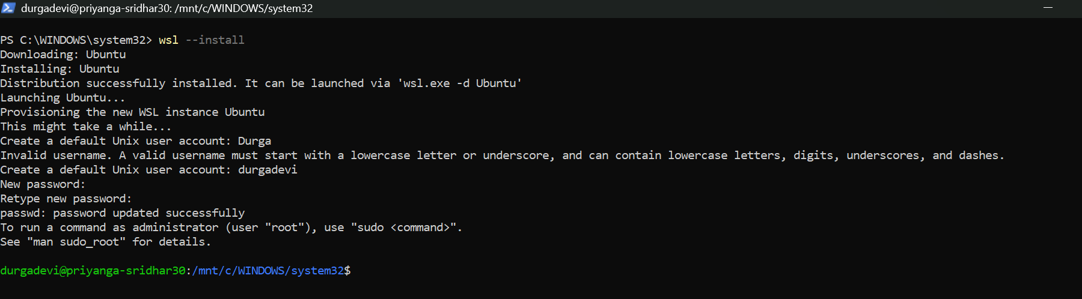

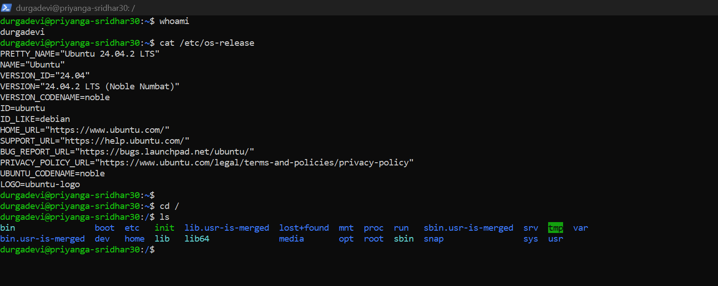

**STEP 2: SET UP DOCKER'S APT REPOSITORY. (INSTALL THE DOCKER PACKAGES)**

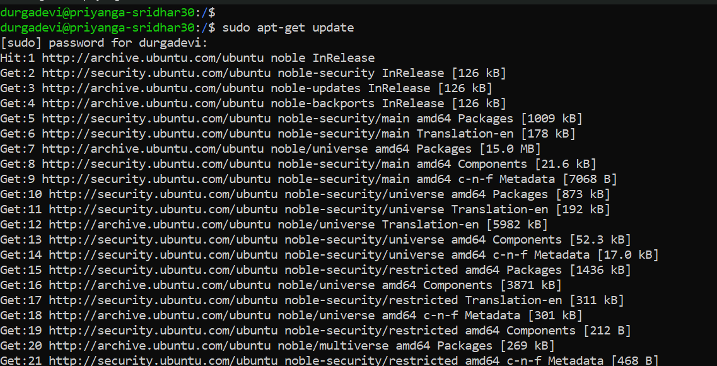

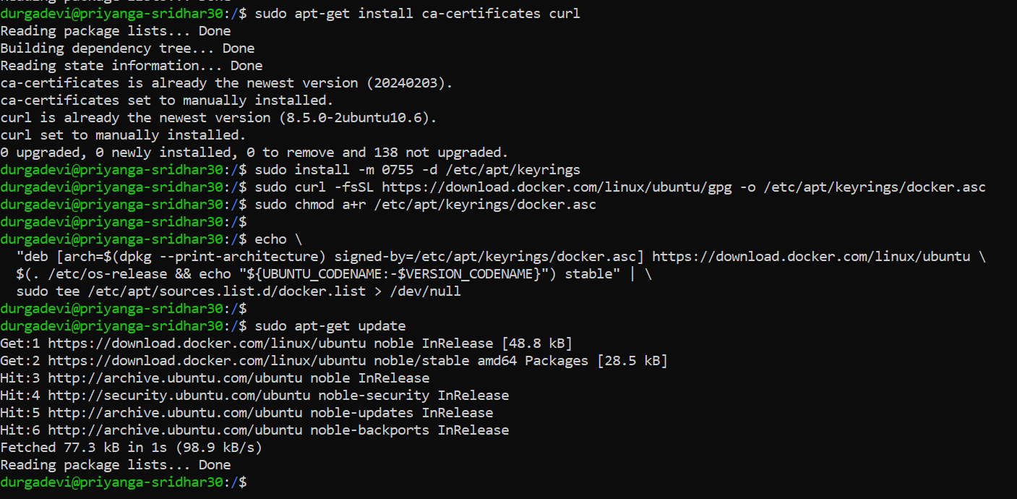

**TO CREATE THE DOCKER GROUP AND ADD YOUR USER:**  
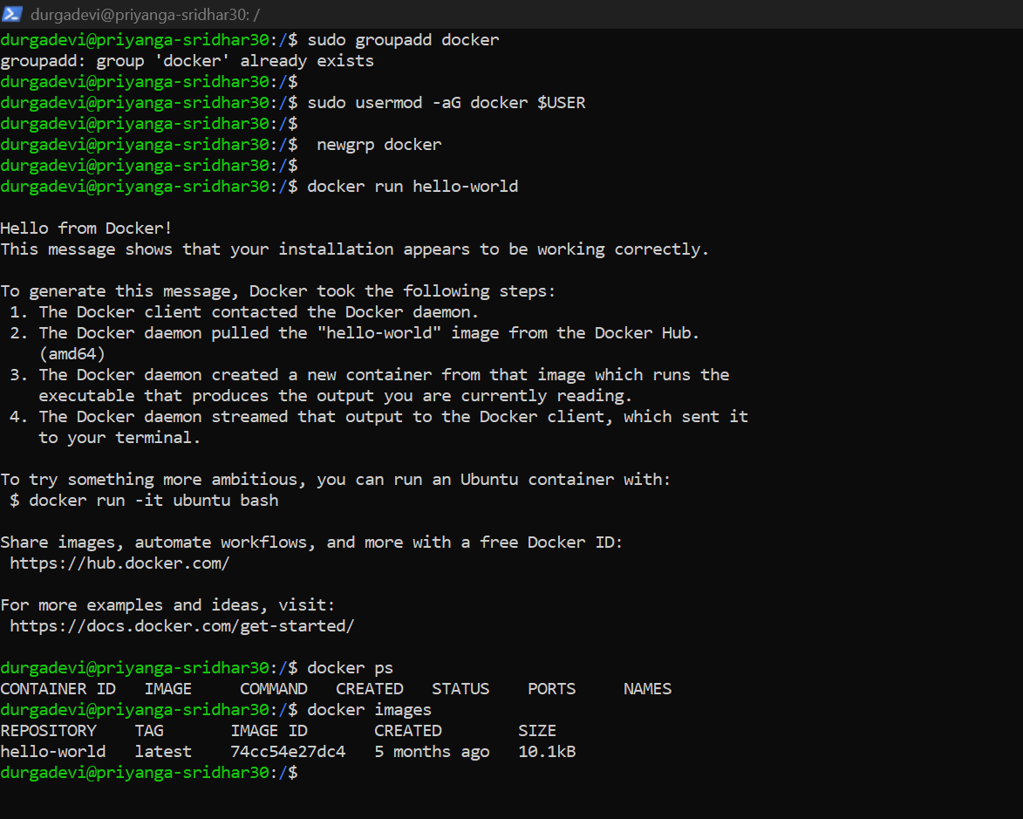

**STEP 4 : INSTALL KUBECTL**

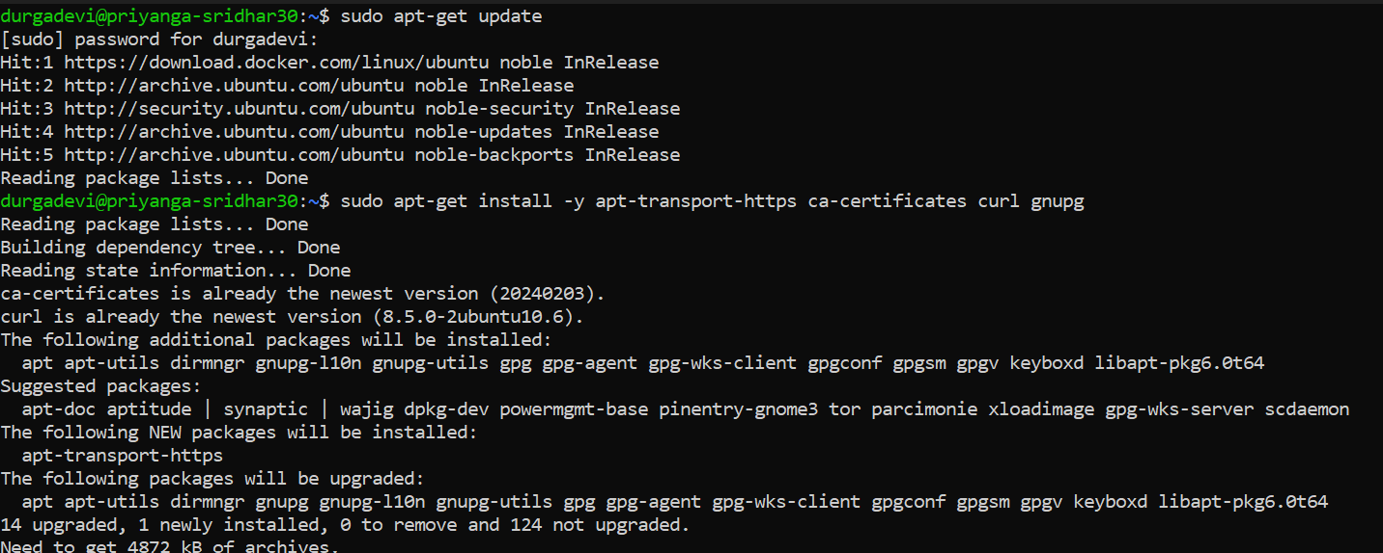

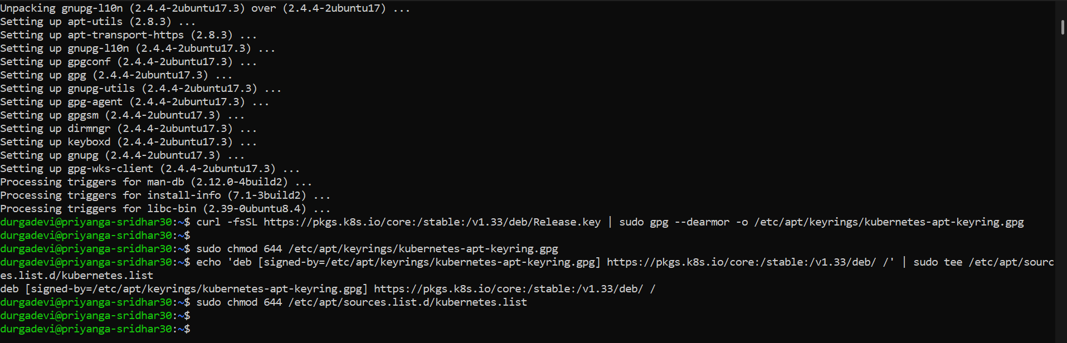

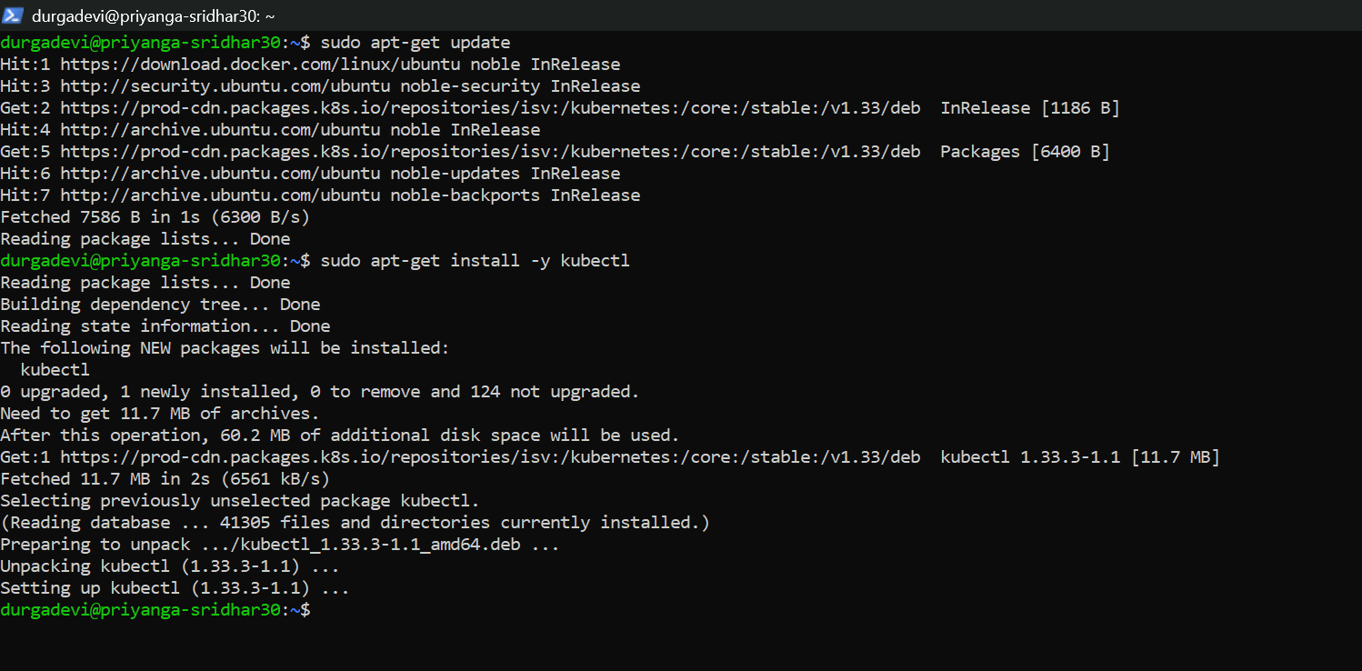

**STEP 5 : INSTALL MINIKUBE**

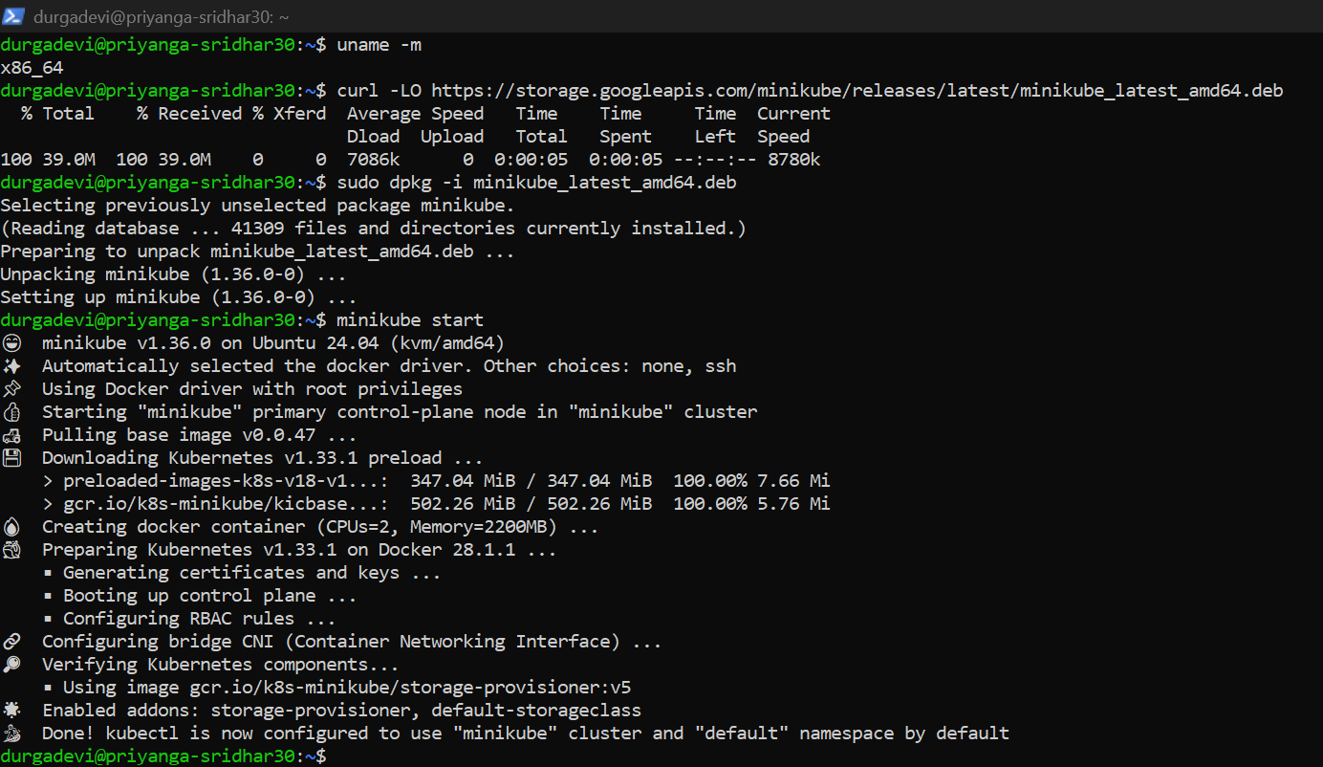

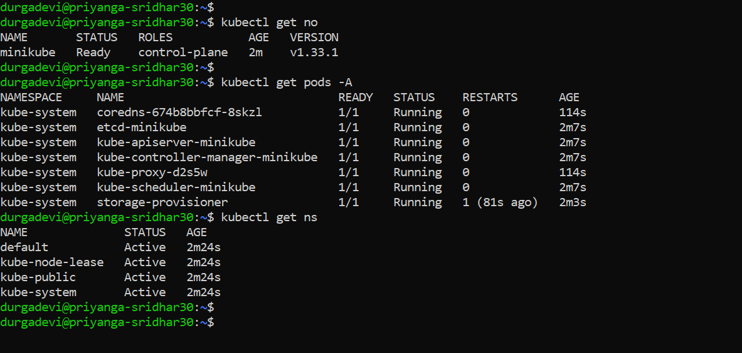

CREATING NAMESPACES

